(a) There is at least three ways to interpret the question:

1) Regard every stock’s 30-day average return as one data point, and we can have two arrays of datapoints, one for most positive standardized excess return stocks and one for most negative standardized excess return stocks. We want to test the hypothesis that these two arrays have the same mean. Using ANOVA method, we have the f-statistic of 3100 and p statistic of 1.5%, which means we can reject the null hypothesis.

2) Regard every stock’s 30-day returns as a sequence of observations, the null hypothesis is that sequences of most positive **or** most negative stocks have the same mean. Use ANOVA method again, we have the f-statistic of 0.55 and p statistic of 82.08% for most positive stocks, so we cannot reject the null hypothesis that most positive stocks have the same mean return. We have p statistic of 82.17% for most negative stocks, so we cannot reject the null hypothesis that most negative stocks have the same mean return.

3) With very similar setup as 2), the null hypothesis is that sequences of most positive **and** most negative stocks have the same mean. Use ANOVA again, the p statistic is now 69.25%, which still can not reject the null hypothesis.

(b) I have prepared two ways to implement and test the idea: one is typical CAR plots in the event window, another is a net value of a simulated fund that implements this strategy over time. If there are multiple holdings in the same day, I assume those holdings are of equal value.

It is also ambiguous whether the n days refers to calendar days or trading days.

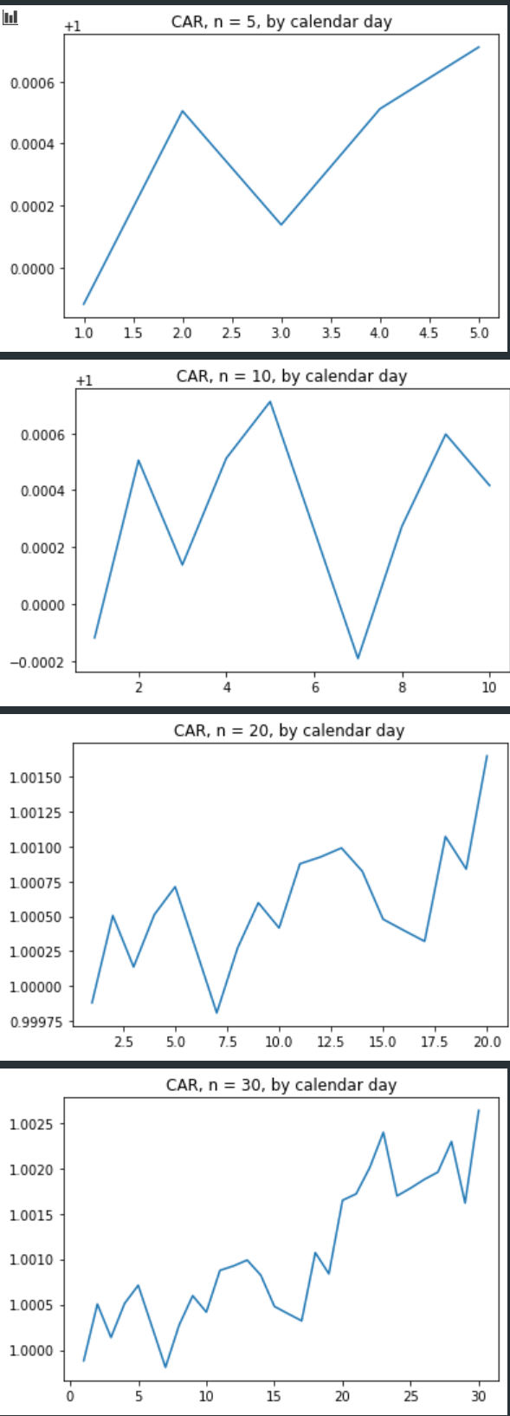 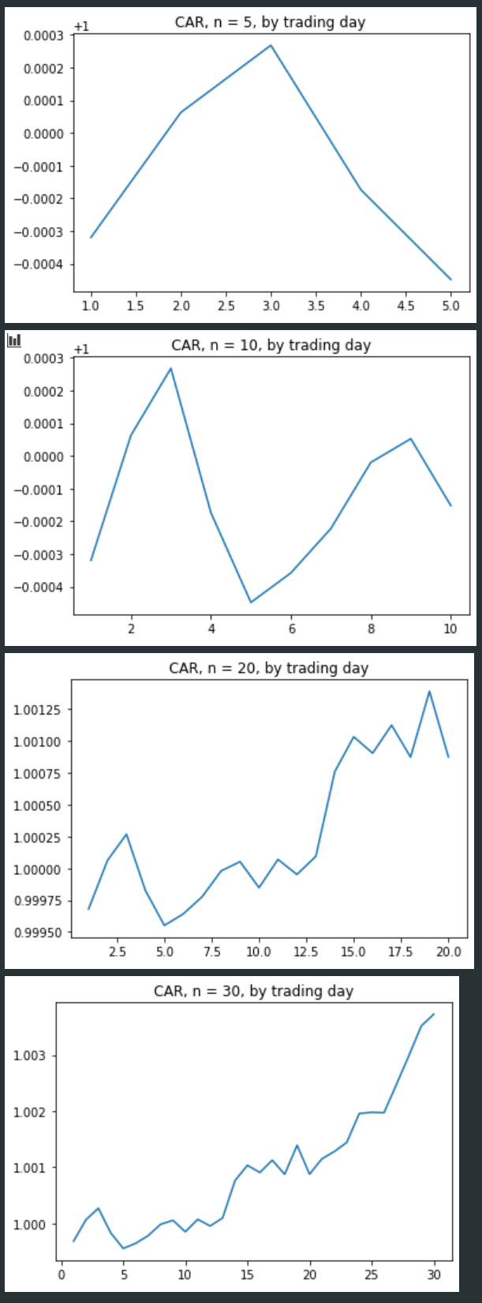

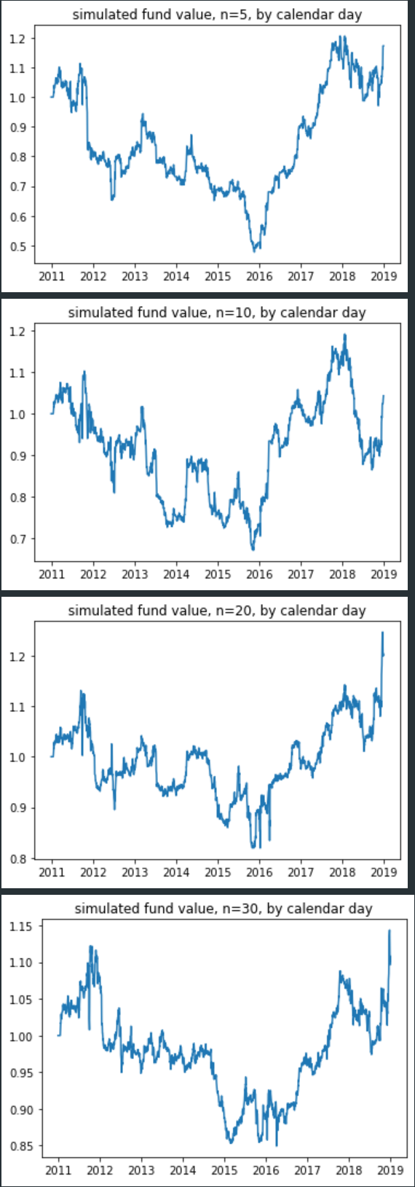 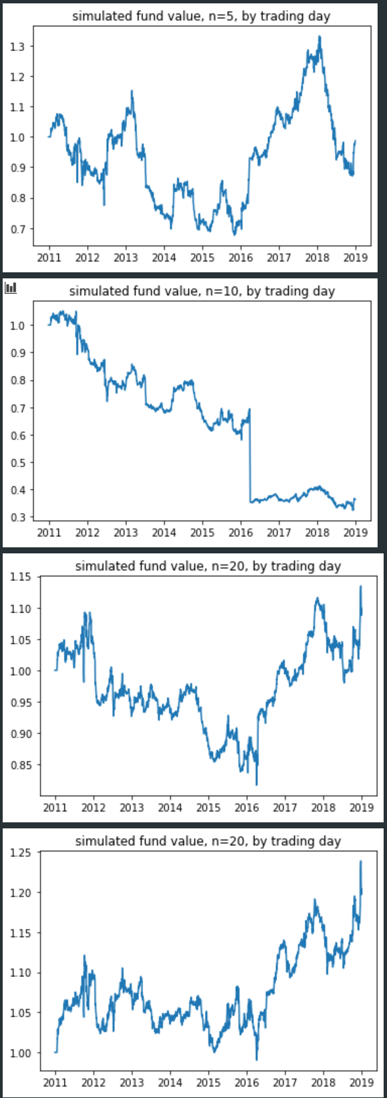

(c) Here we regress the simulated fund values against daily three-factor models. All eight funds represent significant negative alphas (details attached in the code file).